**SQL Training**

### Attention

1. The <XXXX> used in this article represents the employee ID. Please replace it with your own employee ID.

### Create data object

#### Create tables and table indexes

Table ：CUX_OM_CUSTOMERS_XXXX

For storing customer information。

| Field | Type | Nullable | Default Value | Description |
| --- | --- | --- | --- | --- |
|  |  |  |  |  |
| CUSTOMER_ID | BIGINT | N |  |  |
| CUSTOMER_NUMBER | VARCHAR(30) | N |  |  |
| CUSTOMER_NAME | VARCHAR(100) | N |  |  |
| TELEPHONE | VARCAHR(50) | Y |  |  |
| START_DATE_ACTIVE | DATE | Y |  |  |
| END_DATE_ACTIVE | DATE | Y |  |  |
| CREATED_BY | BIGINT | N |  |  |
| CREATION_DATE | DATE | N |  |  |
| LAST_UPDATED_BY | BIGINT | N |  |  |
| LAST_UPDATE_DATE | DATE | N |  |  |
| LAST_UPDATE_LOGIN | BIGINT | Y |  |  |

Create indexes：

| Index | Unique | Field | Description |
| --- | --- | --- | --- |
|  |  |  |  |
| CUX_OM_CUSTOMERS_XXXX_U1 | Y | CUSTOMER_ID |  |
| CUX_OM_CUSTOMERS_XXXX_U2 | Y | CUSTOMER_NUMBER |  |
| CUX_OM_CUSTOMERS_XXXX_U3 | Y | CUSTOMER_NAME |  |

Table：CUX_OM_ITEMS_XXXX

For storing product information。

| Field | Type | Nullable | Default Value | Description |
| --- | --- | --- | --- | --- |
|  |  |  |  |  |
| ITEM_ID | BIGINT | N |  |  |
| ITEM_NUMBER | VARCHAR(30) | N |  |  |
| ITEM_NAME | VARCHAR(100) | N |  |  |
| UOM_CODE | VARCHAR(25) | Y |  |  |
| START_DATE_ACTIVE | DATE | Y |  |  |
| END_DATE_ACTIVE | DATE | Y |  |  |
| CREATED_BY | BIGINT | N |  |  |
| CREATION_DATE | DATE | N |  |  |
| LAST_UPDATED_BY | BIGINT | N |  |  |
| LAST_UPDATE_DATE | DATE | N |  |  |
| LAST_UPDATE_LOGIN | BIGINT | Y |  |  |

Create indexes：

| Index | Unique | Field | Description |
| --- | --- | --- | --- |
|  |  |  |  |
| CUX_OM_ITEMS_XXXX_U1 | Y | ITEM_ID |  |
| CUX_OM_ITEMS_XXXX_U2 | Y | ITEM_NUMBER |  |

table：CUX_OM_HEADERS_XXXX

For storing sales order header information。

| Field | Type | Nullable | DefaultValue | Description |
| --- | --- | --- | --- | --- |
|  |  |  |  |  |
| HEADER_ID | BIGINT | N |  |  |
| ORG_ID | BIGINT | Y | 101 |  |
| ORDER_NUMBER | VARCHAR(30) | N |  |  |
| CUSTOMER_ID | BIGINT | Y |  |  |
| ORDER_DATE | DATE | N |  |  |
| ORDER_STATUS | VARCHAR(30) | Y |  | status list:  UNAPPROVED  APPROVED  CANCELLED  CLOSED |
| DESCRIPTION | VARCHAR(240) | Y |  |  |
| CREATED_BY | BIGINT | N |  |  |
| CREATION_DATE | DATE | N |  |  |
| LAST_UPDATED_BY | BIGINT | N |  |  |
| LAST_UPDATE_DATE | DATE | N |  |  |
| LAST_UPDATE_LOGIN | BIGINT | Y |  |  |
| ATTRIBUTE_CATEGORY | VARCHAR(30) | Y |  |  |
| ATTRIBUTE1 | VARCHAR(150) | Y |  |  |
| ATTRIBUTE2 | VARCHAR(150) | Y |  |  |
| ATTRIBUTE3 | VARCHAR(150) | Y |  |  |
| ATTRIBUTE4 | VARCHAR(150) | Y |  |  |
| ATTRIBUTE5 | VARCHAR(150) | Y |  |  |
| ATTRIBUTE6 | VARCHAR(150) | Y |  |  |
| ATTRIBUTE7 | VARCHAR(150) | Y |  |  |
| ATTRIBUTE8 | VARCHAR(150) | Y |  |  |
| ATTRIBUTE9 | VARCHAR(150) | Y |  |  |
| ATTRIBUTE10 | VARCHAR(150) | Y |  |  |
| ATTRIBUTE11 | VARCHAR(150) | Y |  |  |
| ATTRIBUTE12 | VARCHAR(150) | Y |  |  |
| ATTRIBUTE13 | VARCHAR(150) | Y |  |  |
| ATTRIBUTE14 | VARCHAR(150) | Y |  |  |
| ATTRIBUTE15 | VARCHAR(150) | Y |  |  |

Create Indexes：

| Index | Unique | Field | Description |
| --- | --- | --- | --- |
|  |  |  |  |
| CUX_OM_HEADERS_XXXX _U1 | Y | HEADER_ID |  |
| CUX_OM_HEADERS_XXXX _U2 | Y | ORDER_NUMBER |  |
| CUX_OM_HEADERS_XXXX _N1 |  | CUSTOMER_ID |  |

Table：CUX_OM_LINES_XXXX

For storing sales order line information。

| Field | Type | Nullable | Default Value | Description |
| --- | --- | --- | --- | --- |
|  |  |  |  |  |
| LINE_ID | BIGINT | N |  |  |
| HEADER_ID | BIGINT | N |  |  |
| LINE_NUMBER | VARCHAR(30) | N |  |  |
| ITEM_ID | BIGINT | N |  |  |
| UNIT_PRICE | DECIMAL(10,2) | Y |  |  |
| QUANTITY | DECIMAL(10,2) | Y |  |  |
| DESCRIPTION | VARCHAR(240) | Y |  |  |
| ADDITION1 | VARCHAR(150) | Y |  |  |
| ADDITION2 | VARCHAR(150) | Y |  |  |
| ADDITION3 | VARCHAR(150) | Y |  |  |
| ADDITION4 | VARCHAR(150) | Y |  |  |
| ADDITION5 | VARCHAR(150) | Y |  |  |
| CREATED_BY | BIGINT | N |  |  |
| CREATION_DATE | DATE | N |  |  |
| LAST_UPDATED_BY | BIGINT | N |  |  |
| LAST_UPDATE_DATE | DATE | N |  |  |
| LAST_UPDATE_LOGIN | BIGINT | Y |  |  |
| ATTRIBUTE_CATEGORY | VARCHAR(30) | Y |  |  |
| ATTRIBUTE1 | VARCHAR(150) | Y |  |  |
| ATTRIBUTE2 | VARCHAR(150) | Y |  |  |
| ATTRIBUTE3 | VARCHAR(150) | Y |  |  |
| ATTRIBUTE4 | VARCHAR(150) | Y |  |  |
| ATTRIBUTE5 | VARCHAR(150) | Y |  |  |
| ATTRIBUTE6 | VARCHAR(150) | Y |  |  |
| ATTRIBUTE7 | VARCHAR(150) | Y |  |  |
| ATTRIBUTE8 | VARCHAR(150) | Y |  |  |
| ATTRIBUTE9 | VARCHAR(150) | Y |  |  |
| ATTRIBUTE10 | VARCHAR(150) | Y |  |  |
| ATTRIBUTE11 | VARCHAR(150) | Y |  |  |
| ATTRIBUTE12 | VARCHAR(150) | Y |  |  |
| ATTRIBUTE13 | VARCHAR(150) | Y |  |  |
| ATTRIBUTE14 | VARCHAR(150) | Y |  |  |
| ATTRIBUTE15 | VARCHAR(150) | Y |  |  |

Create Indexes：

| Index | Unique | Field | Description |
| --- | --- | --- | --- |
|  |  |  |  |
| CUX_OM_LINES_XXXX _U1 | Y | LINE_ID |  |
| CUX_OM_LINES_XXXX _N1 |  | HEADER_ID |  |
| CUX_OM_LINES_XXXX _N2 |  | ITEM_ID |  |

#### Import data

excel：《1 – Table Data.xls》

1．CUX_OM_CUSTOMERS_XXXX

2．CUX_OM_ITEMS_XXXX

4．CUX_OM_HEADERS_XXXX

5．CUX_OM_LINES_XXXX

### Questions

#### NO.01

Please create the above objects in the database: table, table index。

-- The name of the database I use --

USE tutorial2manual;

-- To create CUX_OM_CUSTOMERS_46322 table --

CREATE TABLE CUX_OM_CUSTOMERS_46322(CUSTOMER_ID bigint NOT NULL,

CUSTOMER_NUMBER varchar(30) NOT NULL,

CUSTOMER_NAME varchar(100) NOT NULL,

TELEPHONE varchar(50),

START_DATE_ACTIVE date,

END_DATE_ACTIVE date,

CREATED_BY bigint NOT NULL,

CREATION_DATE date NOT NULL,

LAST_UPDATED_BY bigint NOT NULL,

LAST_UPDATE_DATE date NOT NULL,

LAST_UPDATE bigint);

-- To check whether the table is available or not --

SHOW tables;

-- To create indexes on CUX_OM_CUSTOMERS_46322 table*

CREATE UNIQUE INDEX CUX_OM_CUSTOMERS_46322_U1 ON CUX_OM_CUSTOMERS_46322(CUSTOMER_ID);

CREATE UNIQUE INDEX CUX_OM_CUSTOMERS_46322_U2 ON CUX_OM_CUSTOMERS_46322(CUSTOMER_NUMBER);

CREATE UNIQUE INDEX CUX_OM_CUSTOMERS_46322_U3 ON CUX_OM_CUSTOMERS_46322(CUSTOMER_NAME);

-- To add primary key besides input it when creating a table --

ALTER TABLE CUX_OM_CUSTOMERS_46322 ADD PRIMARY KEY (CUSTOMER_ID);

-- To create another table named as CUX_OM_LINES_46322 --

CREATE TABLE CUX_OM_LINES_46322(LINE_ID bigint NOT NULL,

HEADER_ID bigint NOT NULL,

LINE_NUMBER varchar(30) NOT NULL,

ITEM_ID bigint NOT NULL,

UNIT_PRICE decimal(10,2),

QUANTITY decimal(10,2),

DESCRIPTION varchar(240),

ADDITION1 varchar(150),

ADDITION2 varchar(150),

ADDITION3 varchar(150),

ADDITION4 varchar(150),

ADDITION5 varchar(150),

CREATED_BY bigint NOT NULL,

CREATION_DATE date NOT NULL,

LAST_UPDATED_BY bigint NOT NULL,

LAST_UPDATE_DATE date NOT NULL,

LAST_UPDATE_LOGIN bigint,

ATTRIBUTE_CATEGORY varchar(30),

ATTRIBUTE1 varchar(150),

ATTRIBUTE2 varchar(150),

ATTRIBUTE3 varchar(150),

ATTRIBUTE4 varchar(150),

ATTRIBUTE5 varchar(150),

ATTRIBUTE6 varchar(150),

ATTRIBUTE7 varchar(150),

ATTRIBUTE8 varchar(150),

ATTRIBUTE9 varchar(150),

ATTRIBUTE10 varchar(150),

ATTRIBUTE11 varchar(150),

ATTRIBUTE12 varchar(150),

ATTRIBUTE13 varchar(150),

ATTRIBUTE14 varchar(150),

ATTRIBUTE15 varchar(150),

PRIMARY KEY(HEADER_ID)

);

CREATE UNIQUE INDEX CUX_OM_LINES_46322_U1 ON CUX_OM_LINES_46322(LINE_ID);

CREATE INDEX CUX_OM_LINES_46322_N1 ON CUX_OM_LINES_46322(HEADER_ID);

CREATE INDEX CUX_OM_LINES_46322_N2 ON CUX_OM_LINES_46322(ITEM_ID);

SHOW tables;

-- To create another table named as CUX_OM_ITEMS_46322 --

CREATE TABLE CUX_OM_ITEMS_46322(ITEM_ID bigint NOT NULL,

ITEM_NUMBER varchar(30) NOT NULL,

ITEM_NAME varchar(100) NOT NULL,

UOM_CODE varchar(25),

START_DATE_ACTIVE date,

END_DATE_ACTIVE date,

CREATED_BY bigint NOT NULL,

CREATION_DATE date NOT NULL,

LAST_UPDATE_BY bigint NOT NULL,

LAST_UPDATE_DATE date NOT NULL,

LAST_UPDATE_LOGIN bigint);

CREATE UNIQUE INDEX CUX_OM_ITEMS_46322_U1 ON CUX_OM_ITEMS_46322(ITEM_ID);

CREATE UNIQUE INDEX CUX_OM_ITEMS_46322_U2 ON CUX_OM_ITEMS_46322(ITEM_NUMBER);

ALTER TABLE CUX_OM_ITEMS_46322 ADD PRIMARY KEY (ITEM_ID);

-- To create another table named as CUX_OM_ITEMS_46322 --

CREATE TABLE CUX_OM_HEADERS_46322(HEADER_ID bigint NOT NULL,

ORG_ID bigint,

ORDER_NUMBER varchar(30) NOT NULL,

CUSTOMER_ID bigint,

ORDER_DATE date NOT NULL,

ORDER_STATUS varchar(30),

DESCRIPTION varchar(240),

CREATED_BY bigint NOT NULL,

CREATION_DATE date NOT NULL,

LAST_UPDATED_BY bigint NOT NULL,

LAST_UPDATE_DATE date NOT NULL,

LAST_UPDATE_LOGIN bigint,

ATTRIBUTE_CATEGORY varchar(30),

ATTRIBUTE1 varchar(150),

ATTRIBUTE2 varchar(150),

ATTRIBUTE3 varchar(150),

ATTRIBUTE4 varchar(150),

ATTRIBUTE5 varchar(150),

ATTRIBUTE6 varchar(150),

ATTRIBUTE7 varchar(150),

ATTRIBUTE8 varchar(150),

ATTRIBUTE9 varchar(150),

ATTRIBUTE10 varchar(150),

ATTRIBUTE11 varchar(150),

ATTRIBUTE12 varchar(150),

ATTRIBUTE13 varchar(150),

ATTRIBUTE14 varchar(150),

ATTRIBUTE15 varchar(150));

ALTER TABLE CUX_OM_HEADERS_46322 ADD PRIMARY KEY (HEADER_ID);

CREATE UNIQUE INDEX CUX_OM_HEADERS_46322_U1 ON CUX_OM_HEADERS_46322(HEADER_ID);

CREATE UNIQUE INDEX CUX_OM_HEADERS_46322_U2 ON CUX_OM_HEADERS_46322(ORDER_NUMBER);

CREATE INDEX CUX_OM_HEADERS_46322_N1 ON CUX_OM_HEADERS_46322(CUSTOMER_ID);

#### NO.02

Please import the corresponding table data in the file: "1 – Table Data.xlsx" into the table。

**Customers**

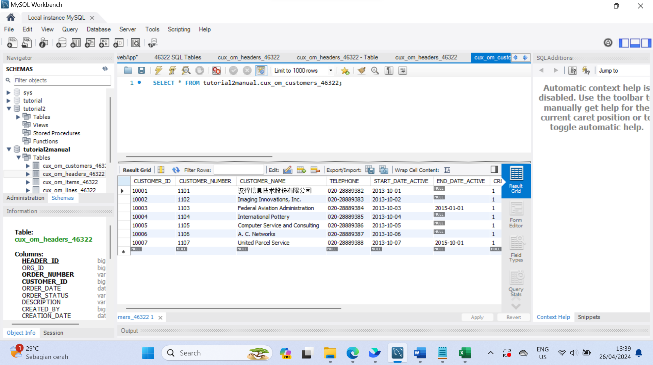

**Headers**

**Items**

**Lines**

#### NO.03

Create a view：CUX_OM_HEADERS_V

* view：CUX_OM_HEADERS_V

| Field | Type | Nullable | DefaultValue | Description |
| --- | --- | --- | --- | --- |
|  |  |  |  |  |
| HEADER_ID | BIGINT | N |  |  |
| ORDER_NUMBER | VARCHAR(30) | N |  |  |
| CUSTOMER_ID | BIGINT | Y |  |  |
| ORDER_DATE | DATE | N |  |  |
| ORDER_STATUS | VARCHAR(30) | Y |  | status list:  UNAPPROVED  APPROVED  CANCELLED  CLOSED |
| DESCRIPTION | VARCHAR(240) | Y |  |  |
| CREATED_BY | BIGINT | N |  |  |
| CREATION_DATE | DATE | N |  |  |
| LAST_UPDATED_BY | BIGINT | N |  |  |
| LAST_UPDATE_DATE | DATE | N |  |  |
| LAST_UPDATE_LOGIN | BIGINT | Y |  |  |
| ATTRIBUTE_CATEGORY | VARCHAR(30) | Y |  |  |
| ATTRIBUTE1 | VARCHAR(150) | Y |  |  |
| ATTRIBUTE2 | VARCHAR(150) | Y |  |  |
| ATTRIBUTE3 | VARCHAR(150) | Y |  |  |
| ATTRIBUTE4 | VARCHAR(150) | Y |  |  |
| ATTRIBUTE5 | VARCHAR(150) | Y |  |  |
| ATTRIBUTE6 | VARCHAR(150) | Y |  |  |
| ATTRIBUTE7 | VARCHAR(150) | Y |  |  |
| ATTRIBUTE8 | VARCHAR(150) | Y |  |  |
| ATTRIBUTE9 | VARCHAR(150) | Y |  |  |
| ATTRIBUTE10 | VARCHAR(150) | Y |  |  |
| ATTRIBUTE11 | VARCHAR(150) | Y |  |  |
| ATTRIBUTE12 | VARCHAR(150) | Y |  |  |
| ATTRIBUTE13 | VARCHAR(150) | Y |  |  |
| ATTRIBUTE14 | VARCHAR(150) | Y |  |  |
| ATTRIBUTE15 | VARCHAR(150) | Y |  |  |
| CUSTOMER_NUMBER | VARCHAR(30) |  |  |  |
| CUSTOMER_NAME | VARCHAR(100) |  |  |  |
| TELEPHONE | VARCHAR(50) | Y |  |  |

CREATE VIEW CUX_OM_HEADERS_V AS SELECT CUX_OM_HEADERS_46322.HEADER_ID, CUX_OM_HEADERS_46322.ORDER_NUMBER, CUX_OM_HEADERS_46322.CUSTOMER_ID, CUX_OM_HEADERS_46322.ORDER_DATE,

CUX_OM_HEADERS_46322.ORDER_STATUS, CUX_OM_HEADERS_46322.DESCRIPTION, CUX_OM_HEADERS_46322.CREATED_BY, CUX_OM_HEADERS_46322.CREATION_DATE, CUX_OM_HEADERS_46322.LAST_UPDATED_BY,

CUX_OM_HEADERS_46322.LAST_UPDATE_DATE, CUX_OM_HEADERS_46322.LAST_UPDATE_LOGIN,

CUX_OM_HEADERS_46322.ATTRIBUTE_CATEGORY, CUX_OM_HEADERS_46322.ATTRIBUTE1,

CUX_OM_HEADERS_46322.ATTRIBUTE2, CUX_OM_HEADERS_46322.ATTRIBUTE3, CUX_OM_HEADERS_46322.ATTRIBUTE4, CUX_OM_HEADERS_46322.ATTRIBUTE5, CUX_OM_HEADERS_46322.ATTRIBUTE6,

CUX_OM_HEADERS_46322.ATTRIBUTE7, CUX_OM_HEADERS_46322.ATTRIBUTE8, CUX_OM_HEADERS_46322.ATTRIBUTE9, CUX_OM_HEADERS_46322.ATTRIBUTE10, CUX_OM_HEADERS_46322.ATTRIBUTE11, CUX_OM_HEADERS_46322.ATTRIBUTE12,

CUX_OM_HEADERS_46322.ATTRIBUTE13, CUX_OM_HEADERS_46322.ATTRIBUTE14, CUX_OM_HEADERS_46322.ATTRIBUTE15, CUX_OM_CUSTOMERS_46322.CUSTOMER_NUMBER, CUX_OM_CUSTOMERS_46322.CUSTOMER_NAME, CUX_OM_CUSTOMERS_46322.TELEPHONE

FROM CUX_OM_HEADERS_46322

LEFT JOIN CUX_OM_CUSTOMERS_46322 ON CUX_OM_CUSTOMERS_46322.CUSTOMER_ID = CUX_OM_HEADERS_46322.CUSTOMER_ID;

#### NO.04

Write SQL to display the following information and sort it by customer_number and order_number in ascending order。

|  |  |  |  |  |  |
| --- | --- | --- | --- | --- | --- |
| order_number | customer_number | customer_name | order_date | order_status | description |
|  |  |  |  |  |  |
|  |  |  |  |  |  |

SELECT CUX_OM_HEADERS_46322.ORDER_NUMBER, CUX_OM_CUSTOMERS_46322.CUSTOMER_NUMBER, CUX_OM_CUSTOMERS_46322.CUSTOMER_NAME,

CUX_OM_HEADERS_46322.ORDER_DATE, CUX_OM_HEADERS_46322.ORDER_STATUS, CUX_OM_HEADERS_46322.DESCRIPTION

FROM CUX_OM_CUSTOMERS_46322 CROSS JOIN CUX_OM_HEADERS_46322 ORDER BY CUSTOMER_NUMBER ASC, ORDER_NUMBER ASC;

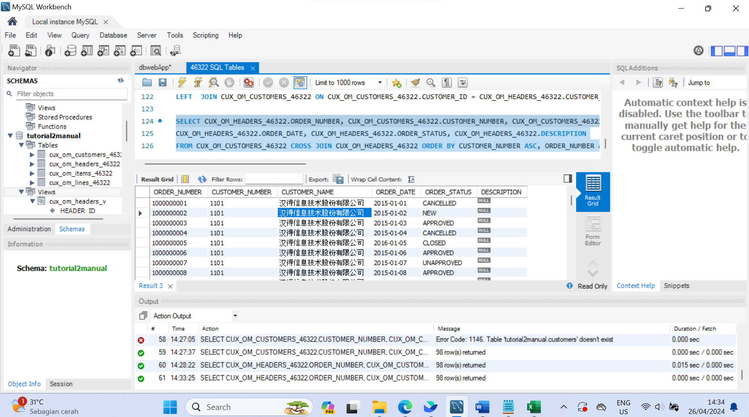

#### NO.05

Write SQL to display order and order line information, sorted by order number and line number in ascending order (including orders with all statuses)

|  |  |  |  |  |  |  |
| --- | --- | --- | --- | --- | --- | --- |
| order_number | customer_name | order_date | order_status | line_number | item_number | item_name |
|  |  |  |  |  |  |  |

#### SELECT CUX_OM_HEADERS_46322.ORDER_NUMBER, CUX_OM_CUSTOMERS_46322.CUSTOMER_NAME,

#### CUX_OM_HEADERS_46322.ORDER_DATE, CUX_OM_HEADERS_46322.ORDER_STATUS, CUX_OM_LINES_46322.LINE_NUMBER, CUX_OM_ITEMS_46322.ITEM_NUMBER,

#### CUX_OM_ITEMS_46322.ITEM_NAME FROM CUX_OM_CUSTOMERS_46322 CROSS JOIN CUX_OM_HEADERS_46322, CUX_OM_LINES_46322,

#### CUX_OM_ITEMS_46322 ORDER BY CUX_OM_HEADERS_46322.ORDER_NUMBER ASC, CUX_OM_LINES_46322.

#### NO.06

Write SQL to display products purchased by customers

|  |  |  |  |  |
| --- | --- | --- | --- | --- |
| customer_number | customer_number | item_number | item_name | uom_code |
| 1101 | 汉得信息技术股份有限公司 | SB86662 | 办公用品 | 个 |

#### SELECT CUX_OM_CUSTOMERS_46322.CUSTOMER_NUMBER, CUX_OM_CUSTOMERS_46322.CUSTOMER_NAME, CUX_OM_ITEMS_46322.ITEM_NUMBER, CUX_OM_ITEMS_46322.ITEM_NAME, CUX_OM_ITEMS_46322.UOM_CODE

#### FROM CUX_OM_CUSTOMERS_46322 CROSS JOIN CUX_OM_ITEMS_46322 WHERE CUX_OM_CUSTOMERS_46322.CUSTOMER_NUMBER = '1101'AND CUX_OM_ITEMS_46322.ITEM_NUMBER = 'SB86662'; A screenshot of a computer Description automatically generated

#### NO.07

Write SQL to count all orders (excluding canceled orders) and calculate the average sales unit price and the highest and lowest unit price by product.

|  |  |  |  |  |
| --- | --- | --- | --- | --- |
| item_number | item_name | average_unit_price | highest_unit_price | lowest_unit_price |
|  |  |  |  |  |

SELECT CUX_OM_ITEMS_46322.ITEM_NUMBER, CUX_OM_ITEMS_46322.ITEM_NAME, AVG(CUX_OM_LINES_46322.UNIT_PRICE),

MAX(CUX_OM_LINES_46322.UNIT_PRICE), MIN(CUX_OM_LINES_46322.UNIT_PRICE)

FROM CUX_OM_ITEMS_46322

INNER JOIN CUX_OM_LINES_46322 ON CUX_OM_ITEMS_46322.ITEM_ID = CUX_OM_LINES_46322.ITEM_ID

INNER JOIN CUX_OM_HEADERS_46322 ON CUX_OM_LINES_46322.HEADER_ID = CUX_OM_HEADERS_46322.HEADER_ID

WHERE CUX_OM_HEADERS_46322.ORDER_STATUS != 'CANCELLED'

GROUP BY CUX_OM_ITEMS_46322.ITEM_NUMBER, CUX_OM_ITEMS_46322.ITEM_NAME;

#### NO.08

Write SQL to query customer information about canceled orders.

|  |  |  |  |  |
| --- | --- | --- | --- | --- |
| customer_number | customer_name | telephone | start_date_active | end_date_active |
|  |  |  |  |  |

#### SELECT CUX_OM_CUSTOMERS_46322.CUSTOMER_NUMBER, CUX_OM_CUSTOMERS_46322.CUSTOMER_NAME, CUX_OM_CUSTOMERS_46322.TELEPHONE,

#### CUX_OM_CUSTOMERS_46322.START_DATE_ACTIVE, CUX_OM_CUSTOMERS_46322.END_DATE_ACTIVE

#### FROM CUX_OM_CUSTOMERS_46322

#### LEFT JOIN CUX_OM_HEADERS_46322 ON CUX_OM_HEADERS_46322.CUSTOMER_ID = CUX_OM_CUSTOMERS_46322.CUSTOMER_ID

#### WHERE CUX_OM_HEADERS_46322.

#### NO.09

Write SQL to count the company's total sales in 2015. (All orders with status CANCELLED are excluded from statistics)

|  |
| --- |
| Total Sales |
|  |

#### SELECT COUNT(CUX_OM_HEADERS_46322.ORDER_STATUS) AS 'Total Sales'

#### FROM CUX_OM_HEADERS_46322

#### WHERE CUX_OM_HEADERS_46322.ORDER_STATUS != 'CANCELLED';

#### A screenshot of a computer Description automatically generated NO.10

Write a script to add an index to the table: CUX_OM_ITEMS_XXXX: a normal index, and the applicable field: ITEM_NAME.

CREATE UNIQUE INDEX CUX_OM_ITEMS_46322_U3 ON CUX_OM_ITEMS_46322(ITEM_NAME);

ALTER TABLE CUX_OM_ITEMS_46322 DROP INDEX CUX_OM_ITEMS_46322_U3;

CREATE INDEX CUX_OM_ITEMS_46322_U3 ON CUX_OM_ITEMS_46322(ITEM_NAME);